**Basic Image Processing**

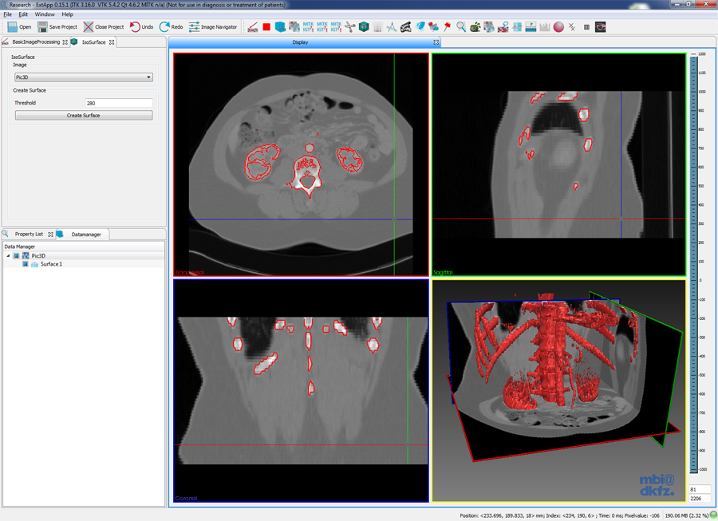

### IGT Tracking

The IGT Tracking plug-in allows you to connect to a tracking device, track and visualize navigation tools and write the tracked data into a log file. Currently the devices Polaris, Aurora (both Northern Digital Inc. (NDI); Waterloo, Ontario, Canada) and Microntracker (Claron Technology, Inc.; Toronto, Ontario, Canada) are supported. The logging feature supports logging in XML or CSV format. Furthermore the plug-in allows for creating and editing navigation tool storages.

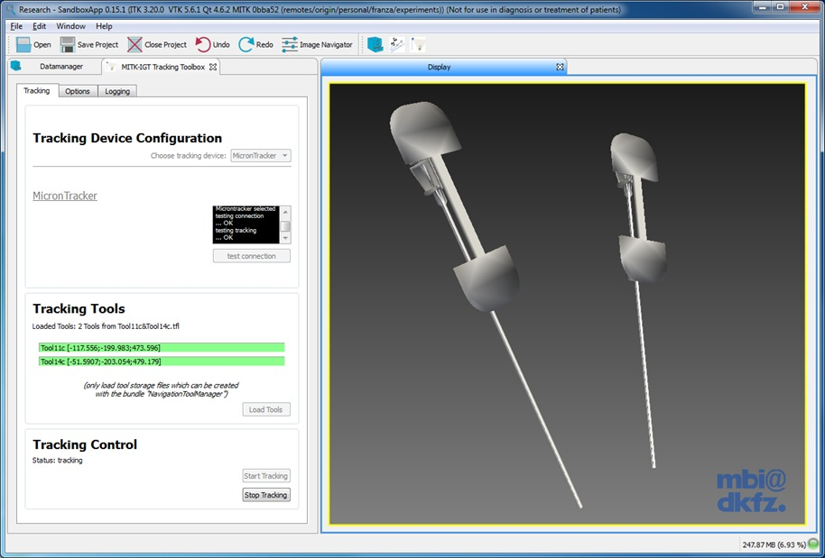

### Iso Surface

### mitkisosurface.png

### Slice Based Segmentation

### slice_based_segmentation.png

### Rigid Registration

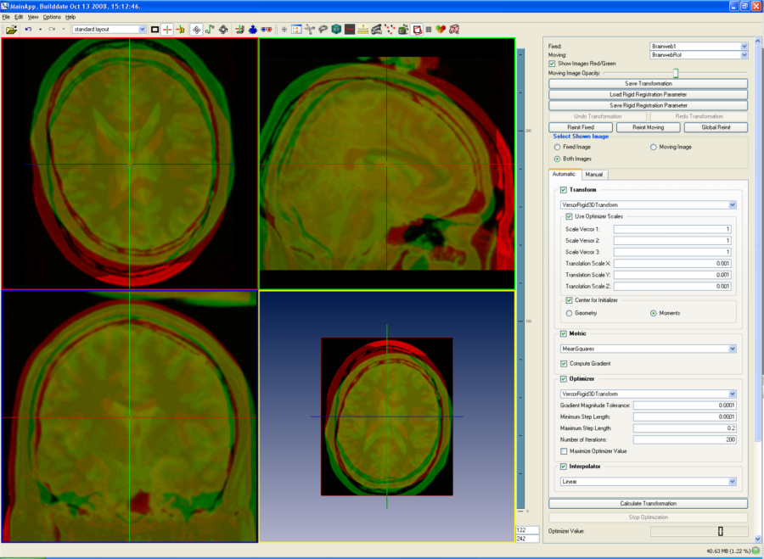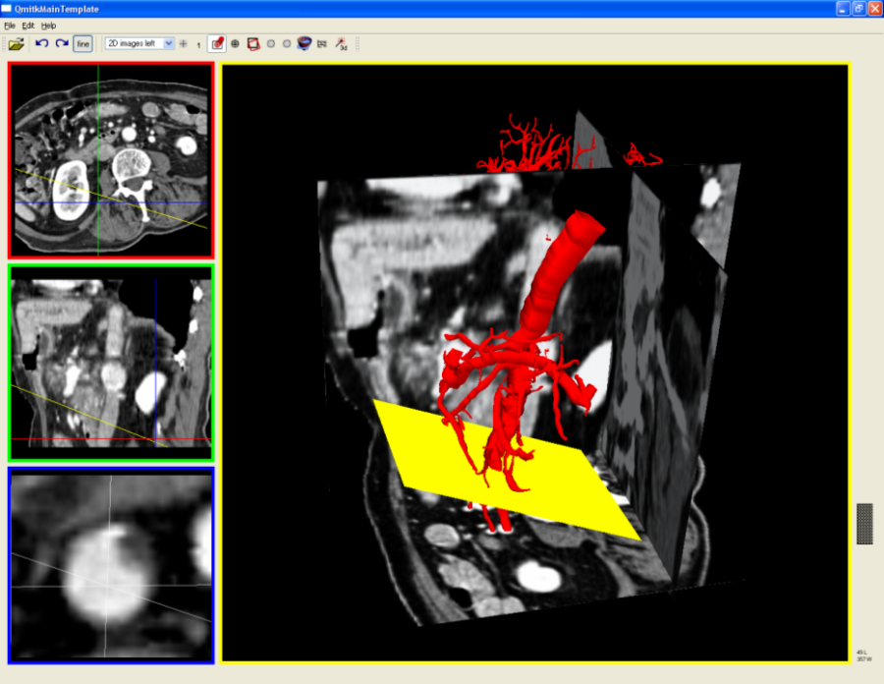

### Automated landmark detection and segmentation for intra-operative C-Arm CT applications

### HeelBones.png

### MitralValveModeling.pngSimulation of Congenital Heart Defect Corrective Surgeries Using Thin Shell Elements

### CongenitalHeartDefect.jpgQuantification of Whole-Body Adipose Tissue

### AdiposeTissueAnalysis.jpgAugmented Reality Navigation System for Laparoscopic Prostatectomy

### LaparoscopicProstatectomy.pngNeedleInsertion.jpg

### ablation1.jpg interactive_fastmarching_level_set_tool.png